


PROJECT REPORT

Prepared by:
Aruana Sadubayeva,Kenessary Garifulla,Arlan Toktarkhan,
Arys Alpys,Ilyas Okenov
Information systems in business
Submitted to:
Alima Dostiyarova

Almaty, 2024-2025

EXECUTIVE SUMMARY

The report aims to provide all the essential analysis and proposed strategy for Colliers’ expansion into the Nigerian real estate market. Beginning with market analysis, indicating the demographic and legal situation in the country. Then it comes to SWOT analysis, showcasing the attractiveness of the Nigeria market for the company. PESTEL analysis provides key insights of the country’s sectors. Key findings from Nurtilek Turdymuratov’s interview on the Colliers’ success in Kazakhstan and discussion of ways to achieve the same success in Nigeria. Madina Bektemissova discussed the main factors for success like building strong local partnerships and establishing relevant services adjusted for the market. Porter’s 5 Forces analysis was conducted, indicating the competitive nature of Nigeria. The entry mode represents the strategies for Colliers to enter the Nigerian market, recommending the joint venture, franchising, wholly-owned subsidiary. The main strategy for Colliers’ expansion highlights the importance of a transnational approach and suggests the engagement in a joint venture.

TABLE OF CONTENTS
1.INTRODUCTION 4
2.SWOT ANALYSIS FOR COLLIERS 5
3.PESTEL ANALYSIS OF NIGERIA 9
4.INTERVIEW FINDINGS 16
5.PORTER’S FIVE FORCES FRAMEWORK 19
6.ENTRY MODE RECOMENDATIONS 21
7.STRATEGY FOR COLLIERS’ EXPANSION INTO NIGERIA 23
8.CONCLUSION 25
9.REFERENCES 26

1.INTRODUCTION

In the case of entering the Nigerian market, it is important to devise a suitable strategy, especially in the case of Colliers, which specializes in the provision of real estate services. With Nigeria having a strong economic base, rapid increase of the urban population, commercial and residential real estates opportunities, an appropriate entry mode will ultimately lead to growth and success. In examining various entry modes, and drawing examples from real estate leaders like Knight Frank and Savills, this analysis proposes the most suitable strategy which will enable Colliers to enter the Nigerian market, and operate successfully.
Market Overview
Nigeria today ranks as the most populous nation in Africa as it currently has a population of over two hundred million people, and thus might serve as a viable market to explore for real estate services. The level of urbanization is high in cities like Lagos, Abuja and Port Harcourt with significant demand for commercial and residential types of properties. However, these cities also have risks such as complex bureaucratic regulations, political risk and lacking infrastructure which would be an essential concern for being tactical and prudent before entering the market.

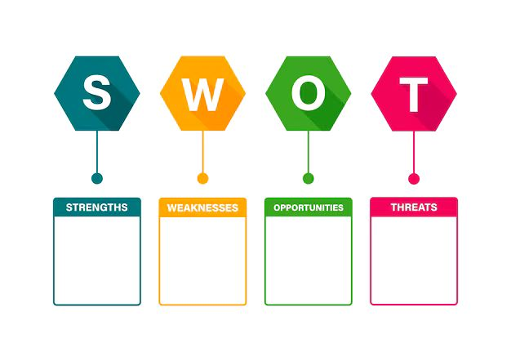
2.SWOT ANALYSIS FOR COLLIERS

-Urbanization and population growth
-Expanding middle class
-Foreign investments
-Tech-driven development
-International reputation
- Diverse services
-Technological superiority
-Experience in emerging markets

-Limited local presence
-Regulatory and legal barriers
-Dependence on expatriates
-Low brand awareness
-Regulatory uncertainty
-Economic volatility
-Infrastructure challenges
-Cultural barriers

Strengths:
International reputation:
Colliers has an impressive influence on the international market and has long been recognized in the real estate and investment management sector for providing professional services worldwide. For example, Colliers already operates in South Africa, which will help the company understand the unique problems of the Nigerian market and find a solution.
Diverse services:
The company offers a diverse portfolio of services, such as real estate services, as well as real estate management, investment services and consulting. This will make it easier for the company to have a diverse customer base.
Technological superiority:
Colliers is already a successful company that has strong financial support and the best technological solutions in the real estate sector, such as real estate valuation using artificial intelligence and real-time market analysis. This allows the company to have a competitive advantage in conducting market analysis, real estate valuation and operational efficiency.
Experience in emerging markets:
Colliers' experience in emerging economies provides confidence that they will cope with the dynamic and often difficult situation in the Nigerian real estate market.
Colliers already has experience working in emerging economies. This will provide confidence that they will be able to cope with the dynamic and often difficult situation in the Nigerian real estate market.

Weaknesses:
Limited local presence:
The company faces difficult competition with already well-established real estate firms in the market, such as UPDC (Local Firm), JLL and Broll Property Group (International firms).
Regulatory and legal barriers:
The Nigerian real estate sector is characterized by complex and contradictory property laws, which can be a major barrier to entry.
In Nigeria, the real estate sector has its own complexities and contradictory property laws. This can be a serious problem for entering the Nigerian market. For example, in 1978, the law on land use came into force, which creates problems when acquiring and renting land. Because land ownership is controlled by the state.
Dependence on foreign experience:
First, Colliers may resort to expatriate services, which will lead to high costs and potential resistance from local stakeholders who prefer initiatives based on local experience.
Low brand awareness:
Even though Colliers is already widely known in the global market, it may be less popular in Nigeria, where customers will trust more familiar local players.

Opportunities:
Urbanization and population growth:
Nigeria has a population of almost 230 million people and continues to grow rapidly day by day. This population growth, combined with rapid urbanization, creates a very high demand for residential, industrial and commercial real estate. For example, the cities of Lagos, Port Harcourt and Abuja are expanding very rapidly and because of this, people with an average income loss have a growing demand for commercial and residential real estate.
Expanding middle class:
Nigeria's growing middle class and a growing number of wealthy people are creating demand for high-quality residential real estate and luxury projects.
In Nigeria, the number of middle-class people and the number of wealthy people is growing, thereby creating demand for high-quality residential real estate and expensive projects. For example, Colliers may focus on managing luxury estates and mixed-use complexes on Banana Island, Lagos.
Foreign investment:
Nigeria is becoming increasingly attractive for foreign investment. For example, in 2022, Nigeria attracted more than $1 billion in foreign real estate investments. The stability of the economy and the potential for high profitability make it an attractive destination for real estate investments.
Threats:
Regulatory uncertainty:
Policies in Nigeria are constantly changing, because of this Colliers may experience delays in project implementation due to unclear property clearance processes, resulting in additional costs.
Economic volatility:
Nigeria is an oil fueled economy, and this places all her property investments at risk due to the volatility that is usually associated with oil prices in the international market.
This dependence especially on a single commodity area poses a great risk for Nigeria. This has been rare of late; nonetheless, Nigeria went through an economic downturn in 2016 due to fluctuations in world oil prices.
Infrastructure challenges:
Nigeria is in Africa and just like the rest of the countries in Africa has poor infrastructure and power supply. Colliers may need to use their funds to improve power and water sources for the properties they manage, which will of course increase operating costs.
Cultural barriers:
In Nigeria, business depends on strong personal relationships. Colliers will take a long time to establish these relationships in the beginning, especially if they do not have a strong local team

3.PESTEL ANALYSIS OF NIGERIA
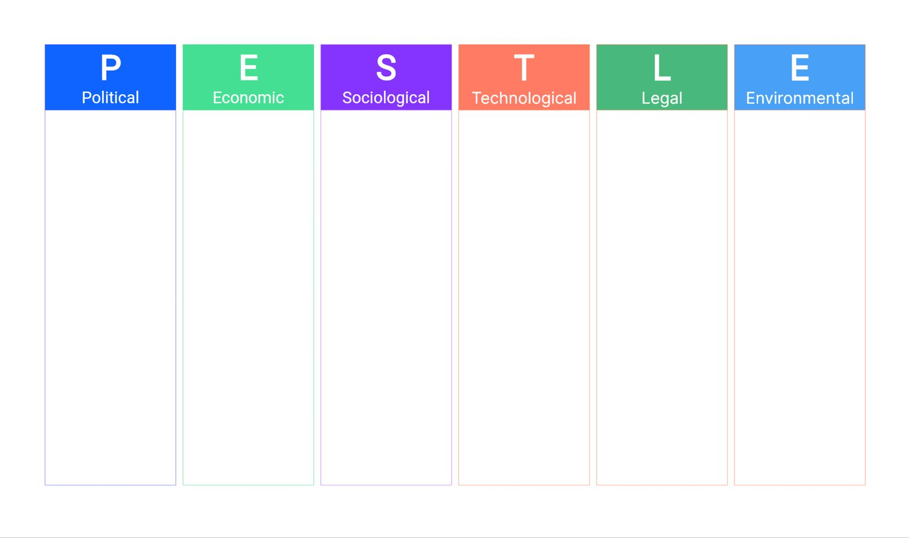

-Leading economy in Africa
-Rapid urbanization
-High inflation and volatile exchange rates
-Growing digital economy
-Complex land ownership laws
-Weak intellectual property enforcement
-Adherence to local labor laws
-Climate change and flooding
-Green building standards
-Industrial real estate near natural resources
-Increasing internet penetration
-Eko Atlantic project
-Digital platforms for real estate marketing
-Mobile-compatible platforms
-Rapid population growth
-Urbanization
-Family-oriented housing preferences
-Literacy rate of 62%
-Political instability
-Government incentives for foreign direct investment
-African Continental Free Trade Agreement
-Complicated property tax system

Political factors:
Nowadays, Nigeria is the country with the long history of political instabilities. Corruption has become the reason of the loss of public trust and economic growth, as it remains deeply entrenched in government and the judiciary authority. According to statistics, about of two thirds of corruption cases happen with political figures intervention. This systemic issue affects citizen safety and creates uncertainty for investors. These could be property dispute risks, contract enforcement risks, and infrastructure delay risks for real estate. While these remain problems, reforms in governance and infrastructure planning-especially in urban centers like Lagos-offer a glimmer of hope for improvement.
The government of Nigeria actively encourages foreign direct investment, with various incentives and simplified procedures. According to the World Bank's 2020 Ease of Doing Business Report, Nigeria moved up 3.5 points, scoring 56.9 out of 100, while the time it takes to start a business has been considerably reduced from the Sub-Saharan average. But unpredictable regulations and enforcement, coupled with sensational corruption cases such as that of Maina pension scam and Ike Ekweremade's jailing, continue to scare away global confidence. Yet, bold initiatives like the fintech VigiPay show Nigeria's new potential to attract genuinely current investment. Real estate investors can also capitalize on any such positive developments in tech-related projects or logistics facilities.
The African Continental Free Trade Agreement opens up opportunities for Nigeria into bigger markets. This will help the manufacturers in Nigeria get cheaper raw materials, new export markets, creating chances to develop industrial real estate. Colliers can take advantage of this development by facilitating trades through its logistics hubs and manufacturing zones.
The property tax system in Nigeria is rather complicated. It consists of various types of taxes, which include land use charge, tenement rates, and stamp duties. These are levied based on the type of property, its use, and market value. MNEs will need to undertake detailed research in this area and, if possible, partner with local firms in order to reduce the risks of delayed commencement or operation of projects.
Economic factors:
Nigeria has the leading economy in Africa. The country is moving from the oil and gas industry to sectors such as agriculture, technology and services, opening new opportunities in the real estate sector. However, continued dependence on oil still exposes the economy to the risk of global price volatility, thus it is hard to predict the market dynamics and whether investment instability can be a problem.
The state of rapid urbanization and the young, growing population has kept demand for residential, commercial, and industrial properties—mostly in cities like Lagos and Abuja—high. Statistical analysis shows that the urban population in Nigeria is growing at about 4.23% yearly, hence showing an increasing need for houses and spaces for commercials. While high unemployment and income inequality are posing challenges for high-end real estate, there has been an increasing demand for affordable housing and mixed-use projects; hence, opportunities for selectively developed projects. High inflation and fluctuating exchange rates may challenge Colliers in the future by increasing construction costs and shrinking profit margins. Since the pandemic crisis the inflation rate has been increasing rapidly, and it has reached a peak of 34.19% this year. Therefore, strategic financial planning and localized sourcing of materials can help mitigate these risks.
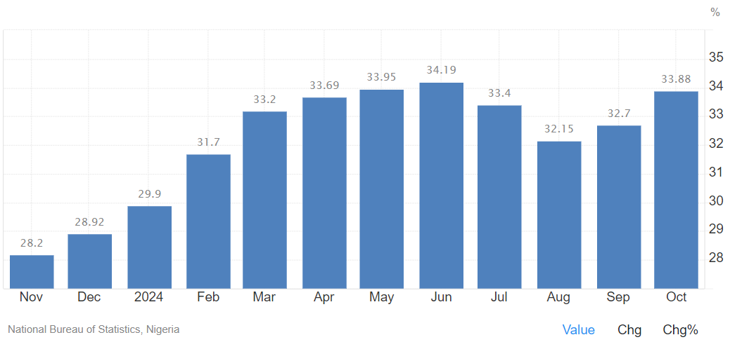
Trading Economics. (n.d.). Nigeria inflation rate. Retrieved December 2, 2024, from https://tradingeconomics.com/nigeria/inflation-cpi

Nigeria’s infrastructure deficits, particularly in power supply and transportation, can impact project timelines and operational costs. However, ongoing infrastructure improvement projects, driven by government and international partnerships, present opportunities for Colliers to invest in supporting real estate, such as logistics hubs and urban redevelopment initiatives.
Nigeria’s growing digital economy and fintech innovations provide opportunities for tech-enabled real estate projects. The expansion of digital infrastructure supports the development of smart cities, logistics hubs, and technology parks, which align with Colliers’ focus on modern and future-ready developments.
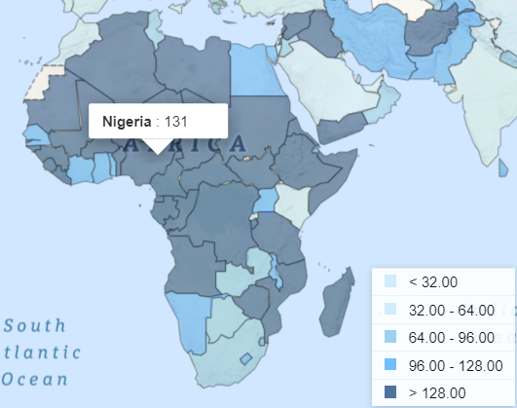
World Bank. (2019). Ease of doing business index. Retrieved December 2, 2024, from https://data.worldbank.org/indicator/IC.BUS.EASE.XQ

Social factors:
In Africa, Nigeria is the fastest-growing country, with more than an estimated demographic figure above 216 million in the year 2022. Projections point towards growing by the year 2050 to approximately 375 million as the third most populated in the world. As for median age in demographics of 18.6 years, the massive demand on accommodation needs could be expected.
The share of the urban population in Nigeria was 54.28%, while the yearly growth rate reached 3.79% by 2023. The entire process of rapid urbanization has increased demand for infrastructural and real estate development in metropolitan centers such as Lagos and Abuja, hence presenting enormous investment opportunities in residential, commercial, and industrial estates.
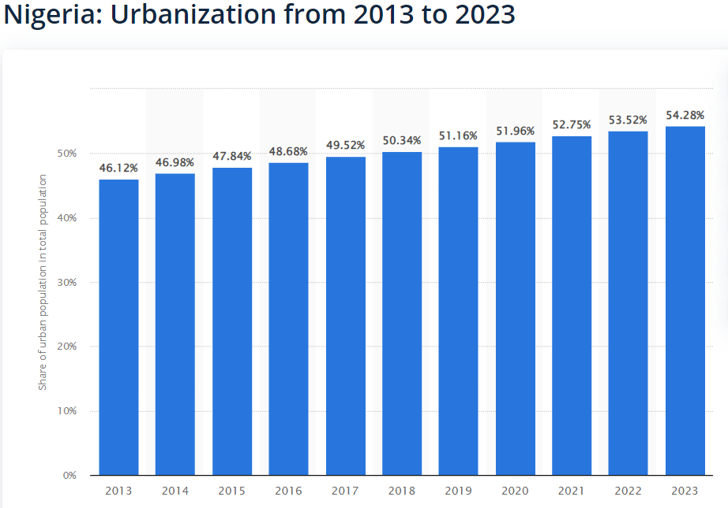

Statista. (n.d.). Urbanization in Nigeria from 2010 to 2020. Retrieved December 2, 2024, from https://www.statista.com/statistics/455904/urbanization-in-nigeria/

Accommodation preferences in Nigeria reflect family-oriented settings, upheld culturally for extended family living arrangements. Such regional traditions and lifestyles need to be understood for successful market entry and the development of real estate projects that will meet consumer expectations.
The literacy rate in Nigeria is about 62%, with a large proportion of the population underemployed, thus providing an opportunity for corporate estate and outsourcing hubs, based on the ready pool of young and educated manpower.

Technological Factors:
The country has noted great development in its digital infrastructure, with up to 163 million internet users by March 2024, which gives it a broadband penetration rate of 43.5%. Such growth encourages the adoption of technology in real estate management and marketing, allowing the use of digital platforms for property listings, virtual tours, and better customer engagement.
Developments like the Eko Atlantic project in Lagos attest to the commitment of Nigeria toward modern urban development. The project will have 250,000 apartments and 150,000 offices under Eko Atlantic. This means that Colliers will participate in large, unique, and sophisticated developments in the African region through this project.
This issue has posed a significant challenge for the construction sector in Nigeria, primarily due to the inadequate incorporation of contemporary technologies, which results in inefficiencies and prolonged project completion times. Therefore, modern construction methods and materials are very important for increased efficiency to meet the challenges of rapid urbanization.
As of January 2023, the country has an internet penetration rate of 55.4%, further boosting its fledgling online presence, helping digital marketing and e-commerce, and ultimately benefiting the retail property sector. The fact that more than 84% of the total internet traffic is from mobile devices underlines the critical importance of mobile-compatible platforms for property marketing and customer interaction.
Environmental factors:
Climate change has caused great floods and destroyed the environment in Nigeria. For instance, the 2022 flooding affected 33 of the 36 states, forced over 1.4 million people to leave their homes, and destroyed over 200,000 houses. These events present the need of strong infrastructure in the most of areas of Nigeria.
The country often struggles with its power supply: the failure of its national grid frequently plunged the nation into blackouts in 2024. Theoretically, the country can generate 12,500 megawatts—where a quarter of the present country's needs exist—but the people depend mostly on diesel generators because of high expenses. That compels an investment in alternatives to both coal and gas—most probably solar or natural gas—especially for property developments that require sure supplies of electricity.
Green building standards are increasingly becoming emphasized in Nigeria, with all the attendant challenges and opportunities that green projects present. This will serve to increase the value of a given property and attract tenants and investors interested in environmentally friendly investments.
Its proximity to vast natural resources is an influence in the development of industrial real estate in Nigeria. Areas that have these resources attract industries, which require special facilities, hence creating opportunities for focused real estate investments.
Legal Factors:
The land ownership system in Nigeria is rather complex with many claims and unclear titles. Under the Land Use Act of 1978, all lands are vested in the government, so a person or an organization has to obtain a Certificate of Occupancy before they can develop anything. This might become a very bureaucratic and long procedure that could slow down projects in the real estate industry. Besides, the customary land rights prevalent in many areas could lead to disputes because of conflicts with the statute laws.
Adherence to local labor laws and practices is of utmost importance, mostly for large projects. The Labour Laws of Nigeria stipulate terms of employment, workers' safety, and dispute resolution. Non-compliance could lead to court cases that may disrupt operations. It is, therefore, very important to understand the regulations and integrate them into planning and execution.
Enforcement of intellectual property laws is relatively weak in Nigeria and may impact the introduction of proprietary technologies or processes. While the legal frameworks for IP protection are in place, their enforcement is irregular, which may result in unauthorized use or replication of proprietary innovations. It is the responsibility of companies, therefore, to put in place strong strategies that will protect their intellectual property while operating in the Nigerian market.

4.INTERVIEW FINDINGS
Interview objective
The interview was conducted to obtain detailed information about Colliers’ strengths, challenges and strategies to assess the company’s readiness to enter the Nigerian market. The contributions of Madina Bektemisova, a student of KBTU Business School and a junior accountant, and Nurtilek Turdymuratov, a junior analyst at Colliers Kazakhstan, helped to provide a comprehensive understanding of the company’s success factors and key aspects to consider when expanding.
Video-interview
The insights discussed in this section are based on a video interview conducted with Nurtilek Turdymuratov on 30.11.2024. The interview provided key perspectives on Colliers company.
Link for the video: https://youtu.be/TfDw-lMdpho?feature=shared
Key Insights
Colliers’ Success Factors in Kazakhstan
Colliers has achieved success in the Kazakhstan market due to several important factors: a wide and diverse client base, an individual approach to solving client requests and a strong team of professionals. As Nurtilek Turdymuratov noted, providing high-quality and personalized reports that meet client requirements sets the company apart from its competitors. A strong network of professional connections and sustainable relationships with clients contribute to the company’s continuous growth and strengthening its reputation.
Key Challenges in Kazakhstan
Colliers’ operations in Kazakhstan face certain challenges. Among the key challenges, Nurtilek highlighted low market transparency, which complicates planning and decision-making. The growing complexity of client requests also creates certain difficulties associated with managing high expectations. These factors require the company to be flexible and innovative in order to remain competitive in a dynamically changing real estate market.
Adapting to the Nigerian Market
To successfully enter the Nigerian market, Colliers will need to adapt its operations. Both interlocutors emphasized the importance of conducting a thorough market analysis to understand local norms, cultural characteristics, and the economic situation. As Nurtilek noted, mechanically copying the approaches used in Kazakhstan will not bring success. Instead, it is necessary to develop a unique business model adapted to the specifics of Nigeria. Madina added that the key factors for success will be establishing trusting relationships with local partners and offering accessible, yet relevant services.
Recommendations for development
To strengthen Colliers’ position locally and internationally, the interlocutors proposed specific steps. Nurtilek recommended expanding the range of services beyond real estate to include asset management and consulting services, which will help diversify revenue sources. He also suggested digitizing the company's reports and making them available to a wider audience to increase transparency and attract new clients. Madina emphasized the importance of using data analytics tools and innovative solutions, especially in emerging markets like Nigeria, where access to quality data can be limited.

Interview participant profiles

Madina Bektemisova
Position: Third-year student at KBTU School of Business, Junior Accountant at RELOG LLP.
Expertise: Accounting, startup support, healthcare projects, including the creation of a startup CERVI for the early detection of cervical cancer.
Contacts: +7 747 490 1083 | bektemisova03@gmail.com


Nurtilek Turdymuratov
Position: Junior Analyst, Colliers Kazakhstan.
Expertise: Data analysis, financial modeling, creation of individual reports for clients.
Contacts: +7 771 676 5497 | Nurtilek.Turdymuratov@colliers.com

5.PORTER’S FIVE FORCES FRAMEWORK

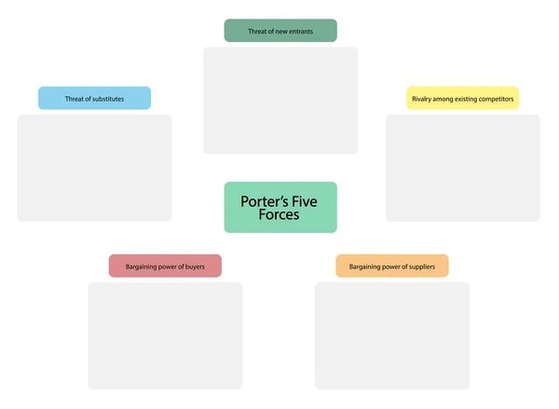
-Moderate to high entry barriers
-Market growth attracts entrants

-High competition intensity
-Presence of global players
-Moderate threat
-DIY and online solutions

-Low to moderate power
-Diverse supplier base
-High buyer power
-Influence of digital platforms

The Nigerian real estate market presents a complex competitive landscape for Colliers, shaped by factors across all five of Porter’s forces.
Threat of New Entrants: Moderate to High
Barriers to entry, such as high capital requirements for infrastructure and compliance with Nigeria’s property laws, deter new players. However, the market’s rapid growth—driven by urbanization (4.3% annual rate) and a population of over 211 million (World Bank, 2021)—attracts entrants. Property technology advancements, such as online tours and blockchain, reduce initial expenses and boost rivalry. Colliers should utilize its worldwide knowledge and create local collaborations to remain competitive.

Bargaining Power of Suppliers: Low to Moderate
With over 5,000 property developers and Nigeria’s $127 billion construction sector (Statista, 2021), supplier power is diluted. Low switching costs enable Colliers to diversify suppliers. However, renowned developers managing high-value properties hold greater influence. Very often approach to deal with aggressive competition is strong relationships with multiple suppliers and leveraging its global market presence.
Bargaining Power of Buyers: High
Buyers, both corporate and individual investors, areunuenced by alternatives such as PropertyPro.ng and Nigeria Property Centre, which oﬀer wide property listings. 108 million internet users have full open source of offers and they do negotiate to make the deal. Colliers can counteract this by providing tailored services, leveraging technology, and building long-term client relationships.
Threat of Substitutes: Moderate
Online platforms and DIY (Do-It-Yourself) solutions enable direct property transactions, but they lack expertise in large-scale deals and legal processes. Colliers can differentiate by offering specialized advisory, leveraging technology, and emphasizing trust and transparency.
Industry Rivalry: High
The market’s growth, contributing 5% to Nigeria’s GDP, attracts intense competition from global firms like JLL and Knight Frank. Colliers can maintain its edge by offering innovative services like sustainability consulting, which aligns with Nigeria’s $24.7 billion green building investment potential (IFC, 2030).
Colliers must focus on innovation, technology adoption, and local adaptation to solidify its market position and achieve long-term success in Nigeria.

6.ENTRY MODE RECOMENDATIONS
Entry Modes Assessment
For a potential entry into Nigeria, Colliers has at least a handful of alternatives. These entry modes have respective merits and demerits attached to them but are exclusive to a certain entry mode depending on how that entry mode fits into Colliers' business model.
1. Exporting
Colliers can export some of its services, such as consulting and more remote operations. This method is good because it is inexpensive, has low investment risks and is suitable for use in pre-sales trials. However, this method is only effective in the short term and will not help to create a strong and sustainable market in Nigeria as there will be high dependence on intermediaries for field operations
2. Licensing
Licensing is also only effective in the short term because there are always limits to the degree of control. With licensing, Colliers can allow local partners to use their intellectual property, techniques or even their brand. Due to the skills of the locals, costs will be lower. However, due to the lack of control, there is a risk of brand dilution and the possibility of pirating intellectual property.
3.Franchising
It also provides Colliers with an avenue of penetrating its brand in Nigeria by collaborating with local partners through the tenets of franchising. It seeks to maintain the global brand equity of Colliers while taking advantage of local expertise. It is a business model that is scalable in a manner that it can help create and promote brand presence within the market. This, however, calls for great franchise management systems and are mostly reliant on the franchisee performance. With those said, franchising remains a realistic mid-term option for Colliers given their unique set of challenges.
4. Joint Ventures
Colliers should seek a joint venture with a suitable Nigerian real estate firm in a way that ensures security and ease of compliance with the regulatory framework in a mode that leverages local knowledge and networks. On the other hand, they may have some disadvantages such as conflicts over who should manage or control the joint venture and distribute profits, as well as dependence on how well the other partner performs. Despite the presence of these risks, this way of entering the company is the most suitable option for Colliers because it provides a good compromise between risks and opportunities.
5. Wholly Owned Subsidiary
Colliers will have absolute operational, branding and strategic control of the Nigerian market if it establishes a wholly owned subsidiary. This strategy is only suitable in the long run. Entering the market with this strategy will cost a lot of money for the company and have high risks. Because of this, it will be more rational to use this strategy after the establishment of the joint venture.
To successfully establish yourself in the real estate market as a Colliers firm, it is essential to partner first with an experienced local real estate company in Nigeria. This strategic partnership will provide an understanding of market dynamics and regulations.
Once an operational base is established, Colliers can then partner with the rest of the companies providing services across the country. This strategic move allows the company to grow effectively.
Once Colliers has gained experience and strengthened its position in Nigeria, it should take charge of its operations in the country to maintain full authority over its services and synchronize its strategies with international goals.
When venturing into the market Colliers can unlock possibilities but it demands a smart strategy to manage risks and seize opportunities. Starting with a venture seems like the way to go as it taps into local knowledge and connections to establish a solid footing, in the market. As we become more familiar with the market and build our brand presence expanding through franchising or owned subsidiaries can secure our success, in the run.

7.STRATEGY FOR COLLIERS’ EXPANSION INTO NIGERIA
The expansion of Colliers into Nigeria is a strategic move that can be explained by rapid urbanization rates, an expanding middle class, and attractive government reforms and policies. The transnational strategy is the most appropriate to expanding into an emerging market that has very different consumer preferences, legal structures, and infrastructure. It would yield an optimum balance between cost efficiency and local responsiveness. However, Colliers’ international agents have to be aware of not only the opportunities but also potential risks associated with this expansion.
One of the growing markets when it comes to real estate is Nigeria due to the rapid urbanization that takes place in such cities as Lagos, Abuja, and Port Harcourt. There is also increasing demand for residential, commercial, and industrial property in view of its youthful population, which is at a high middle-class component. However, cross-cultural features are very important to take into account because of the difference in consumer preferences, religions, languages, cultures and infrastructure between regions. For example, property design, payment structures, and legal systems are all different, which requires special approaches to meet local expectations while sustaining operational efficiency.
Colliers can engage in a joint venture with a well-established Nigerian real estate company, drawing on local expertise and market presence to handle such complexities. The partnership would therefore allow Colliers to adapt its services to the local taste and preference, thereby developing economies of scale through shared resources and knowledge. The ideal partner would be one that has established market intelligence and distribution channels, such as Northcourt Real Estate or Estate Intel, who have a very great insight into trends within the Nigerian real estate sector.
A transnational strategy would, therefore, relate to the adaptation of services to local market imperatives, such as flexible financing options for homebuyers or commercial property solutions that can be tailored to the needs of local businesses. Meanwhile, Colliers can achieve cost efficiencies by centralizing other activities, such as the adoption of technology or property management frameworks. This two-prong approach has allowed the company to play off the peculiarities of the Nigerian market while competing efficiently on costs.

Nevertheless, there are quite a few challenges that the Nigerian market will throw up for Colliers to surmount strategically: political instability, including the security situation in some states, might affect operational continuity; economic volatility, high inflation, and fluctuating currency values increase financial risk; and legal complications due to the amalgamation of English law, customary law, and Sharia law need to be cautiously addressed to ensure compliance. Therefore, a joint venture will enable Colliers to share these risks with a local partner who knows such intricacies and, consequently, will reduce exposure to such uncertainties.
The transnational strategy, moreover, befits the kind of regulatory environment often imposed in Nigeria, which places a premium on local partnership and acquiescence to government imperatives. Partnership with a Nigerian firm would therefore imply commitment to contributing to the local economy and might therefore curry goodwill with both the authorities and other stakeholders. This helps in building trust with consumers who like services that are sensitive to their cultural and economic contexts.
Therefore, the expansion of Colliers into Nigeria through a transnational strategy and a joint venture with a local estate firm positions it to leverage the growth opportunities while managing the challenges in an effective manner. In this regard, the company is better positioned in the value creation for the customers in Nigeria, adaptability toward the local situations, and cost efficiencies toward sustainable success in the competitive and dynamic market.

8.CONCLUSION
Colliers’ expansion into the Nigerian property market presents significant opportunities driven by rapid urbanization, a growing middle class and government incentives for foreign investment. However, this opportunity is accompanied by challenges such as regulatory complexity, inadequate infrastructure and economic instability.
A cross-border strategy supported by joint ventures with established local partners is the most viable approach. This strategy allows Colliers to adapt to local market conditions while leveraging its international expertise. Building strong partnerships, embracing cultural sensibilities and investing in innovative and technical solutions are essential to long-term success.
By carefully managing risk and seizing growth opportunities, Colliers has established itself as a market leader in Nigeria’s dynamic property sector.

9.REFERENCES
Sivesan, S., Thiruchelvam, S., & Paranirupasingam, G. (2019). Legal factors affecting construction projects: A case study in Jaffna. Organization, Technology & Management in Construction: An International Journal, 11(1), 1911–1922. https://doi.org/10.2478/otmcj-2019-0009
Investment Monitor. (n.d.). FDI in Nigeria: Oil, gas, and diversification opportunities. Retrieved November 27, 2024, from https://www.investmentmonitor.ai/features/fdi-nigeria-investment-africa-oil-gas-diversification/
AP News. (2024, September 14). Nigeria’s nationwide power outage caused by total collapse of electricity grid. Retrieved November 27, 2024, from https://apnews.com/article/nigeria-nationwide-power-outage-electricity-3efa0ec13c42280d4a67d2d561a24322
Wikipedia. (n.d.). Demographics of Nigeria. Retrieved November 27, 2024, from https://en.wikipedia.org/wiki/Demographics_of_Nigeria
Willcocks, L. (2012). Global business management foundations. Steve Brooks Publishing.
Next Move Strategy Consulting. (n.d.). Nigeria real estate market report. Retrieved November 27, 2024, from https://www.nextmsc.com/report/nigeria-real-estate-market
Vines Realty. (n.d.). Nigeria’s real estate market analysis with compelling facts. Retrieved November 27, 2024, from https://www.vinesrealtyng.com/post/nigeria-s-real-estate-market-analysis-with-compelling-facts
Northcourt Real Estate. (2024). 2024 Nigeria real estate market outlook - Summary. Retrieved November 27, 2024, from https://northcourtrealestate.com/download/2024%20Nigeria%20Real%20Estate%20Market%20Outlook%20-%20SUMMARY.pdf
Trading Economics. (n.d.). Nigeria inflation rate. Retrieved December 2, 2024, from
https://tradingeconomics.com/nigeria/inflation-cpi
Sivesan, S., Thiruchelvam, S., & Paranirupasingam, G. (2019). Legal factors affecting construction projects: A case study in Jaffna. Organization, Technology & Management in Construction: An International Journal, 11(1), 1911–1922. https://doi.org/10.2478/otmcj-2019-0009
World Bank. (2019). Ease of doing business index. Retrieved December 2, 2024, from https://data.worldbank.org/indicator/IC.BUS.EASE.XQ
AP News. (2024, September 14). Nigeria’s nationwide power outage caused by total collapse of electricity grid. Retrieved November 27, 2024, from https://apnews.com/article/nigeria-nationwide-power-outage-electricity-3efa0ec13c42280d4a67d2d561a24322
Northcourt Real Estate. (2024). 2024 Nigeria real estate market outlook - Summary. Retrieved November 27, 2024, from https://northcourtrealestate.com/download/2024%20Nigeria%20Real%20Estate%20Market%20Outlook%20-%20SUMMARY.pdf

